As the parent/guardian of the children specified below, I certify that I have strong personal and religious beliefs against the practice of immunization/vaccination. I am opposed to having my children allegedly immunized against all vaccinations.
[Child Name] – Birth Date: [Child Birth Date]
I understand that if an outbreak of what the Utah Department of Health considers a “vaccine-preventable disease” occurs for which my child is exempted, the child for whom this exemption is claimed, is to be excluded from the school for the duration of the outbreak and/or threat of exposure. My child will be allowed back only when a health department representative is satisfied that there is no longer a risk of contracting or transmitting a “vaccine-preventable disease.”
I hereby notify that my child is exempted from the Utah Immunization Rule for Students (R396-100) due to our personal and religious opposition to immunizations.
The above statement was provided to use in May 2017 by school district Legal Counsel after extended discussions on the rights of parents. This statement is more than sufficient to comply with the legal requirement for opting out of immunizations based on either personal or religious beliefs. However for the education of the reader, I provide the following additional information.
Also, in previous encounters with Utah’s education system, the Director of the Utah Department of Health has personally and directly declared that it is up to each school to make their own decisions on accepting parental opt outs. I appreciate your timely acceptance of this opt out notice in compliance with Utah’s legal and constitutional acknowledgement of the rights of parents.

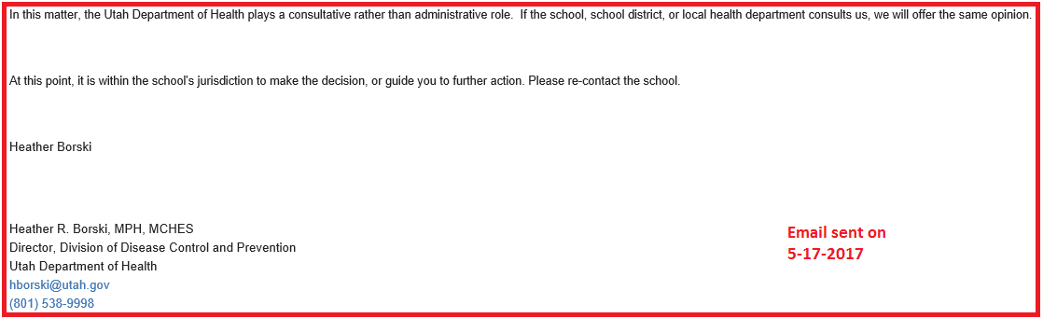
Utah law and the Utah State Constitution recognize that parental rights are superior to other interests and allows for parents to make decisions for their children in all matters. Therefore I have submitted this statement signed by me (a parent or guardian) stating our personal and religious exemptions. Additionally, to be compelled to sign any form in order to exercise my rights is a violation of my rights under the Fifth Amendment to the U.S. Constitution.
It is our deeply held religious belief that the body is a temple and that life is sacred, as aborted fetal tissue and unsafe and untested ingredients are used in these vaccines. It is also my religious belief that parents have a sacred stewardship to keep their children safe and allowing a government entity to compel families by law into any medical treatment is a violation of my religious freedom guaranteed by the First Amendment to the U.S. Constitution and the natural and common law that the constitution was based on. The practice of vaccination and the injection of any foreign substance into our bodies that we believe to be harmful is contrary to our religious convictions based on our personal communications with the God we worship and the written scripture which we believe to be correct. This exemption is given as part of exercising our religious belief under the First Amendment to the U.S. Constitution and also for the safety of my child.
We do not need permission to exercise our constitutional rights as parents, nor can we be compelled to go through any bureaucratic process before our rights are granted to us. Those rights existed and may be exercised by us simply stating them, as we have done here.
Membership in a religion is not a requirement to comply with the law. Our legal rights are guaranteed by the free exercise clause of the First Amendment to the U.S. Constitution. Recent court decisions have upheld the rights of individuals seeking exemptions from immunizations based upon personal and religious reasons. On the U.S. Supreme Court level in Frazee V. Illinois Dept. of Security, 489 U.S. 829, it was found that a state may not deny an exemption simply because a person is not a member of a formal religious organization.
Additionally, applicable federal code states that a religious belief is subject to protection even though no religious group espouses such beliefs or the fact that the religious group to which the individual professes to belong may not advocate or require such belief. Title VII of the Civil Rights Act of 1964 as amended Nov. 1, 1980; C.F.R. Title 29 1605.1-Guidelines on Discrimination Because of Religion.
Cornell Law Library: (https://www.law.cornell.edu/cfr/text/29/1605.1)
Direct Federal Code link: (https://www.gpo.gov/fdsys/pkg/CFR-2011-title29-vol4/xml/CFR-2011-title29-vol4-part1605.xml)
Reference cases:
United States v. Seeger, 380 U.S. 163 (1965)
Welsh v. United States, 398 U.S. 333 (1970)
As parents have a sacred stewardship to keep their children safe, I disagree with the opinion stated on the Utah state provided exemption form that not vaccinating my child poses a risk. My actions avoid the many dangers that would otherwise be a threat to my child, and even to others from “vaccine shedding”. The Gardasil vaccine is known to cause side effects as serious as death. Modern outbreaks of Polio and Whooping cough almost always happen in populations that are already vaccinated, and therefore the vaccines are a serious suspect in the cause, and not prevention, of these diseases.
The attenuated virus used to produce the Rubella vaccine (RB27/3) was obtained from an aborted fetus and then cultivated on fetal tissue from another aborted baby (WI-38), and is also in the rubella portion of the MMR-II vaccine. The Chickenpox vaccine containing WI-39, MRC-5 and Hepatitis-A vaccine (MRC-5) were obtained from human babies that were electively aborted. A conflict arises because my religious convictions are predicated on the belief that all life is sacred. God’s commandment “Thou Shalt Not Kill” applies to the practice of abortion. The acceptance of these vaccines promotes abortion and violates the Sixth Commandment. The Hepatitis-B vaccine protects against a disease that is only transmitted through sexual activity, and the acceptance of this vaccine promotes sexual promiscuity and immoral behavior in direct contradiction to the teachings of my faith.
Thank you for respecting our first amendment rights, under the US Constitution, and respecting this personal and religious exemption from vaccination, and other medical treatment that I do not approve of.

-------------------------------------------------------------------------------------------------------
[Father’s Name] (Father) (Date)
[Home Address]

-------------------------------------------------------------------------------------------------------
[Mother’s Name] (Mother) (Date)
[Home Address]

